Problem 1:

Write a function spinWords that takes in a string of one or more words, and returns the same string, but with all five or more letter words reversed

Strings passed in will consist of only letters and spaces. Spaces will be included only when more than one word is present.

Examples:

spinWords( "Hey fellow warriors" ) => returns "Hey wollef sroirraw"

spinWords( "This is a test") => returns "This is a test"

spinWords( "This is another test" )=> returns "This is rehtona test"

Solution:

<https://replit.com/@captainTOKIO/Problem-Solving#main.py>

def spinwords(sentence):

#it is divided into individual words according to the spaces.

a=sentence.split(' ')

b=''

for i in a:

# if the word length is greater than or equal to 5, it needs to be flipped.

if len(i)>5:

i=i[::-1]

b+=i+" "

else:

b+=i+" "

return b

print(spinwords('Hey fellow warriors'))

print(spinwords('This is a test'))

print(spinwords('this is another test'))

**4.**[**Median of Two Sorted Arrays**](https://leetcode.com/problems/median-of-two-sorted-arrays)

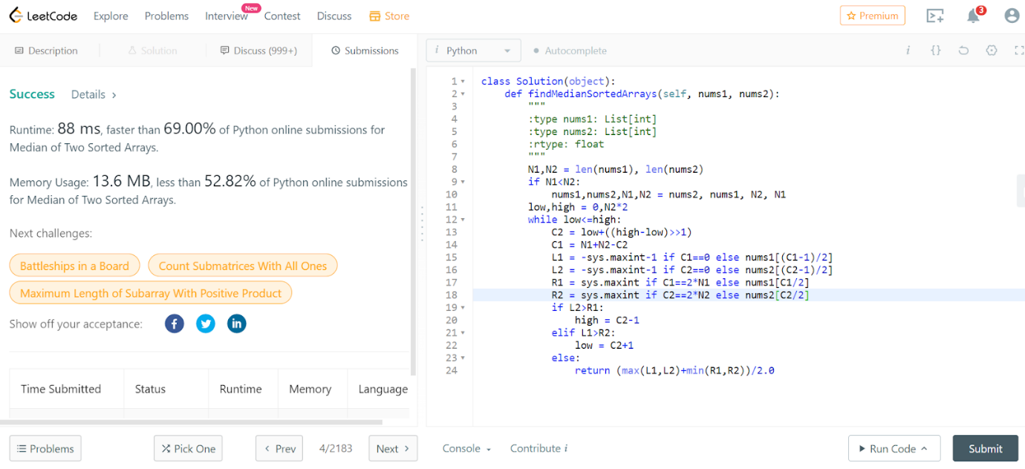

class Solution(object):

    def findMedianSortedArrays(self, nums1, nums2):

        """

        :type nums1: List[int]

        :type nums2: List[int]

        :rtype: float

        """

        N1,N2 = len(nums1), len(nums2)

        if N1<N2:

            nums1,nums2,N1,N2 = nums2, nums1, N2, N1

        low,high = 0,N2*2

        while low<=high:

            C2 = low+((high-low)>>1)

            C1 = N1+N2-C2

            L1 = -sys.maxint-1 if C1==0 else nums1[(C1-1)/2]

            L2 = -sys.maxint-1 if C2==0 else nums2[(C2-1)/2]

            R1 = sys.maxint if C1==2*N1 else nums1[C1/2]

            R2 = sys.maxint if C2==2*N2 else nums2[C2/2]

            if L2>R1:

                high = C2-1

            elif L1>R2:

                low = C2+1

            else:

                return (max(L1,L2)+min(R1,R2))/2.0